1. Database Index
2. Form:
3. Generic:

(we just build these two tables using json2python.py)

1. Search result with index
2. Choose “ascending” to search for its precise position based on index.

Result:



Therefore, the precise position for “ascending” is

metadata -> jsonQuery -> order -> order[0] ->

ascending

1. Choose “flags” to search for its precise position based on index.

Result:



Therefore, the precise position for “flags” is

grants -> grants[0] -> flags

1. Choose “flags1” to search for its precise position based on index.(In order to distinguish flags from other metadata named flags,we add suffix “1” as the mark )

Result:



(the result is obtained by output.py)

1. Find specific element with index in MongoDB
2. insert the json file into Mongodb

mongoimport --db test --collection test --file test.json

1. find specific element without index in MongoDB

example 1: we want to find "flags" : [ "public" ]

result:



example 2 :we want to find "ascending" : false

result:



1. find specific element with index in MongoDB

example 1: "flags" : [ "public" ]

the precise postion :grants -> grants[0] -> flags

(from the python script)

input: 

output:



example2: "ascending" : false

the precise position: metadata -> jsonQuery -> order -> order[0] -> ascending (from python script)

input: 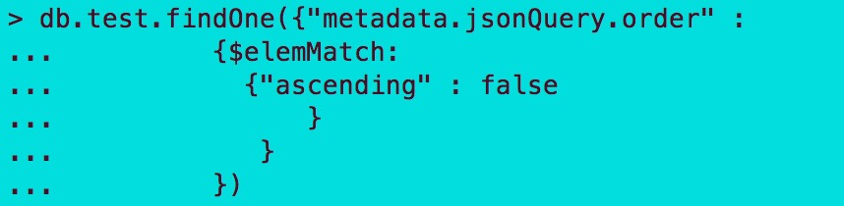

output:

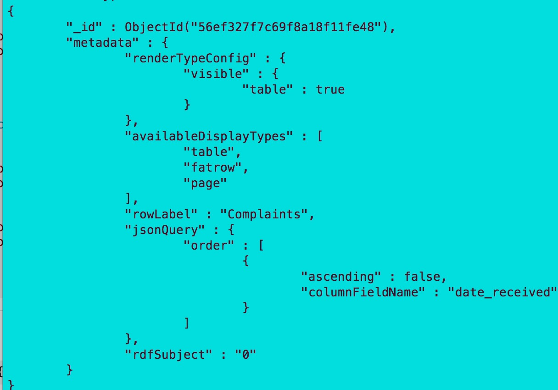

From the above examples,it can be seen that in order to find the specific element ,we need the index which provides the precise position of it.

1. Conclusion

In MongoDB,When we want to find the specific element in the json file,especially the complex nested array json file,we may merely know the internal key and value for this element.However,based on this conditions,the element can not be found effectively and we may even need to check it by self.Therefore,we just build the index with elements to provide the whole position of elements in the json file.With index,we can find it more efficiently.